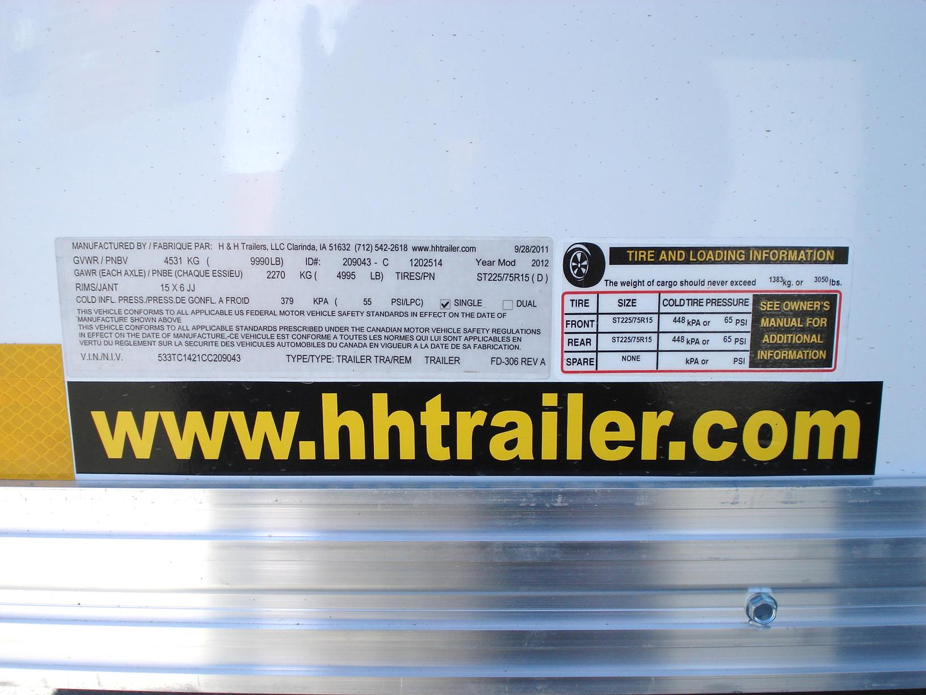

I need to check on the boxes highlighted in yellow.

